Part 1: Capture DNS Traffic

Step 1: Download and install Wireshark.

Step 2: Capture DNS traffic.

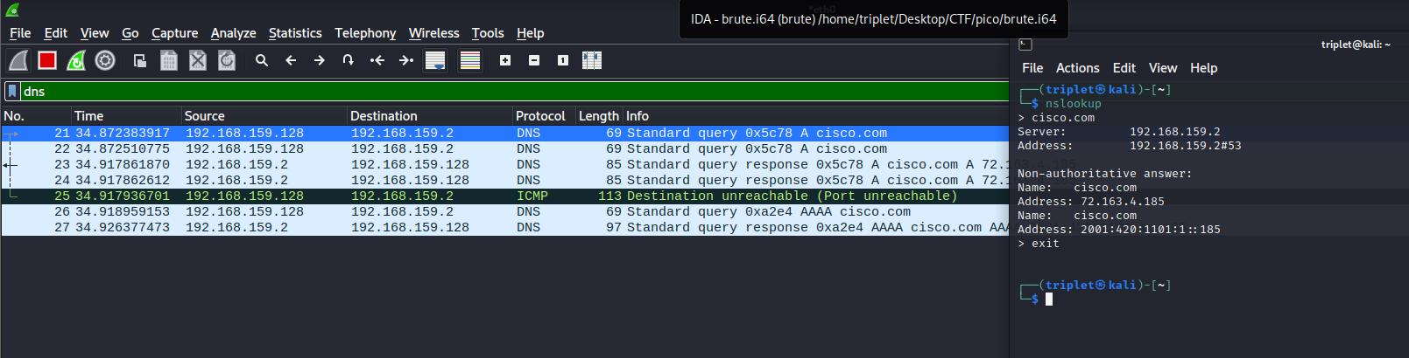

Part 2: Explore DNS Query Traffic

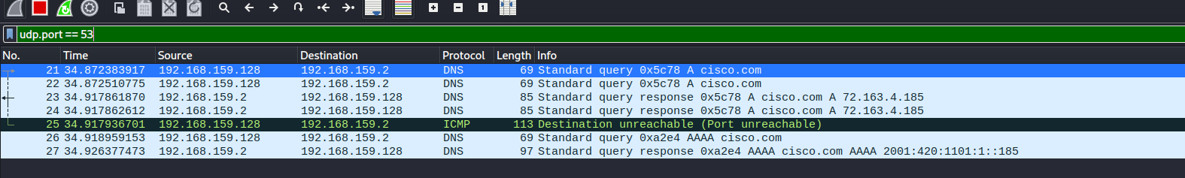

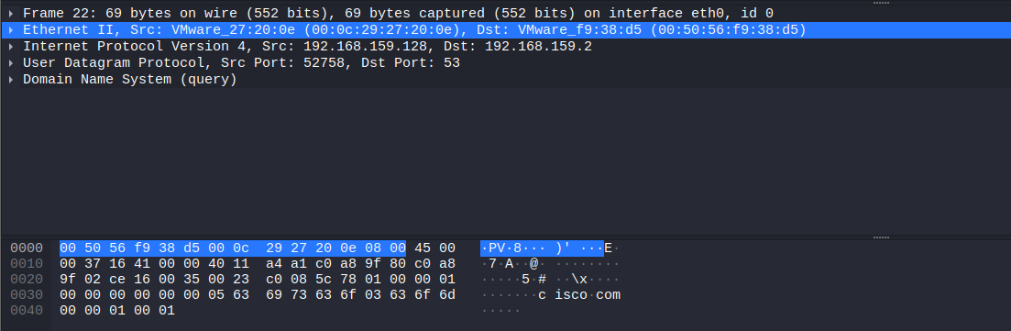

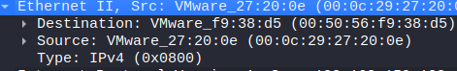

Des MAC: 00:50:56:f9:38:d5 (VMWare)

Src MAC: 00:0c:29:27:20:0e (VMWare)

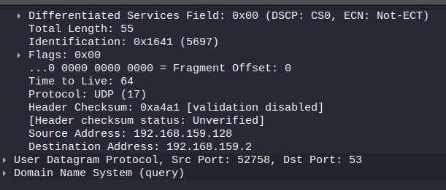

Des IP: 192.168.159.2

Src IP: 192.168.159.128

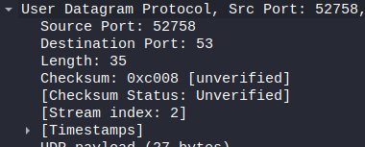

Des Port: 53

Src Port: 52758

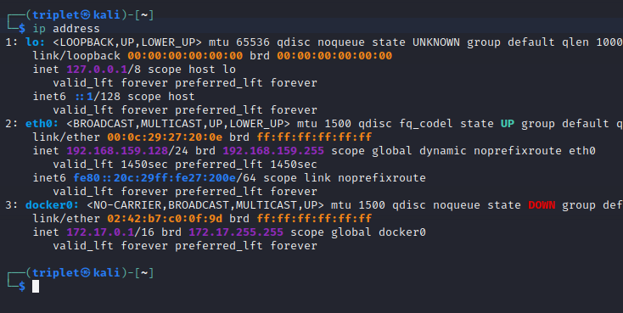

Same address as Wireshark

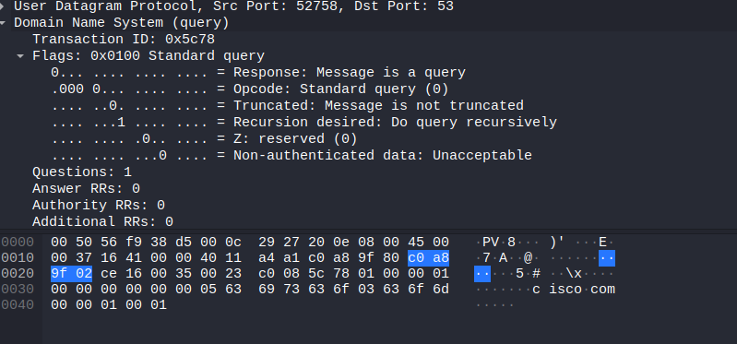

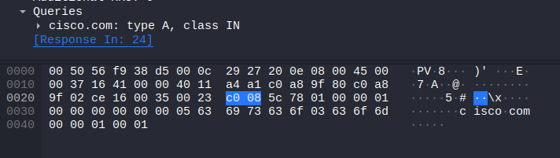

Part 3: Explore DNS Response Traffic

